Quakers and Young People at the Heart of Quaker Life.

A Report for the Children and Junior Young Friends Committee of Australia Yearly Meeting.

Fiona Gardner

March, 2024.

Acknowledgements: many thanks to Di Bretherton for her generous support as well as to the members of the Children and Junior Young Friends Committee and the many people who contributed a wealth of experience and ideas.

Advices and Queries 20: How can we make the meeting a community in which each person is accepted and nurtured and strangers are welcome? Seek to know one another in the things that are eternal, bear the burden of each other’s failings and pray for one another.

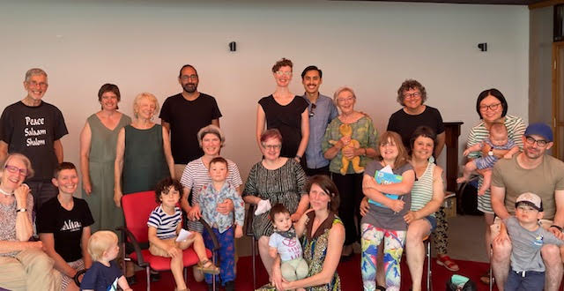
A celebration of new babies at Victoria Regional Meeting!

Background:
Australia Yearly Meeting 2022 recommended that the Australian Children and Junior Young Friends’ Committee employ a paid worker with relevant experience in social research to
• identify and consider the needs of meetings, families and young people;
• build community, relationships and support for those working with families and young people;
• connect people with similar challenges, ideas and needs; and
• consult with other YMs and learn from their experiences (e.g. A/NZ).
The aim was to provide a way forward for supporting families and young people within AYM.

After some initial difficulty in filling the position, the Children and JYFs Committee asked Fiona Gardner, an experienced researcher from La Trobe University to carry out a research project titled: Children and Young People at the Heart of Quaker Life in May, 2023. She and a research colleague, Jill Hanlon, met with four groups of Friends including Hobart, Victoria and South Australian Regional Meetings and individuals across all states, a total of 50 people overall including some children and JYFs to explore current and past experiences of how Meetings have sought to include all ages, what is being done well and what we could do better. The Committee hopes this summary of what emerged will be used to foster the inclusion of all ages in Quaker communities in Australia.

Introduction:
Quakers are not alone in wrestling with what a post-Covid world means. Some other faith traditions are also finding that the Covid years have exacerbated existing issues and opened up both new opportunities and challenges including whether their tradition will survive. In Australia, some Friends have long advocated for more active inclusion of children and young people in our Quaker community expressed for example in Backhouse lectures from Tracey Bourne (2014) Australian Young Friends (2010) and Helen Bayes (2003). These raise a fundamental question of whether we see children and JYFs as integral to our Meetings, equal and life-giving partners.

During Covid, we became accustomed to not going to Meetings in person, but rather connecting online and the numbers of children and JYFs involved dropped significantly. Online Meetings mean that people can connect across Australia – and internationally which has been life-enhancing for many. For others this has meant loss of the informal contact and community building that can come from in person Meetings for Worship. This has been particularly so in fostering mutual understanding: it’s easier to value the idiosyncratic qualities of adults and exuberance of children you know and feel connected to.

What then was lost and what was gained? What does all this mean for who are we now as a Quaker community? This project asked: how do we make sure that people of all ages feel welcome and included in our Meetings with a particular focus on children and young people and their families?

What has emerged from talking with Australian Friends is:
Families, children and JYFs see their Quaker community as important, but often feel welcomed by individuals rather than the Meeting as a whole. Many Meetings have little or no separate formal and safe space for children. Parents fear judgements about noise and energy. Acceptance is needed of a wider range of diversity related to changing family patterns, to gender and neurodiversity for children and adults.

Most parents want ideally to be able to attend Meetings for their own spiritual nurture as well as for their children. If we want parents to come, Meetings need to be able to care for the children rather than parents necessarily becoming the child carers by default. Parents are happy to contribute to this, provided it is not always their role or always the same parents.

Children and JYFs want to be part of Quaker community but now have expectations which reflect their cultural and educational experience: to be actively engaged in activities and discussions rather than be formally ‘taught’ Quaker values. This needs to be balanced with how we provide knowledge of Quaker ways, history and the variety of Quaker spiritual experiences – which is also wanted particularly by JYFs.

Children and JYFs want to be with others of similar ages (and so with different expectations related to independence) and have time to come to know each other as well as the wider Quaker community – just as Quaker adults do. They want both regular time, not necessarily weekly and blocks of time in person (though not excluding on line as needed and once they know each other) and a balance of structured and more informal time together. Sundays are now often days of competing activities with other family members (given parents are living separately) or sport. We also need to recognise that the clear age groupings for children, JYFs and Young Friends don’t fit everyone: some flexibility is needed.

Meetings vary considerably in their capacity to cater for children and young people and have responded often in creative ways (examples in appendix): for example, having a ‘just in case’ roster with resources at hand, encouraging children and families to come on a particular Sunday of the month to help create a ‘critical mass’ of children.

Not everyone feels physically or emotionally able to care for children at a particular time. Quakers are also an ageing community: some feel less confident to care for or embrace the exuberance of children. Others, who may be parents, grandparents, Young Friends or other members and attenders remain actively committed to caring for children but are concerned lack of consistent childcare means children may not come and ask will Quakers survive? Some have experienced the pressure and exhaustion of being seen as the children’s organiser rather than the Meeting as a whole taking responsibility. Some Young Friends are interested in supporting children and JYFs but may need financial support to get to activities.

There are welcome but more complex expectations now of ensuring safety for children. These are recognised as essential, but some feel confused about the difference between formal Quaker activities needing approved child carers and informal activities that parents might arrange together. Some have found it time consuming to be registered as a child carer. The Child Protection Committee has recognised these issues and a new policy is available now for consultation.

Some Friends also affirm the need for greater creativity about what we offer all ages, but particularly families and how we simplify decision making about what can be offered and how to ensure such creativity is encouraged. Many stressed asking families and Young Friends what their suggestions and preferences would be, recognising that some Young Friends are parents and others not.

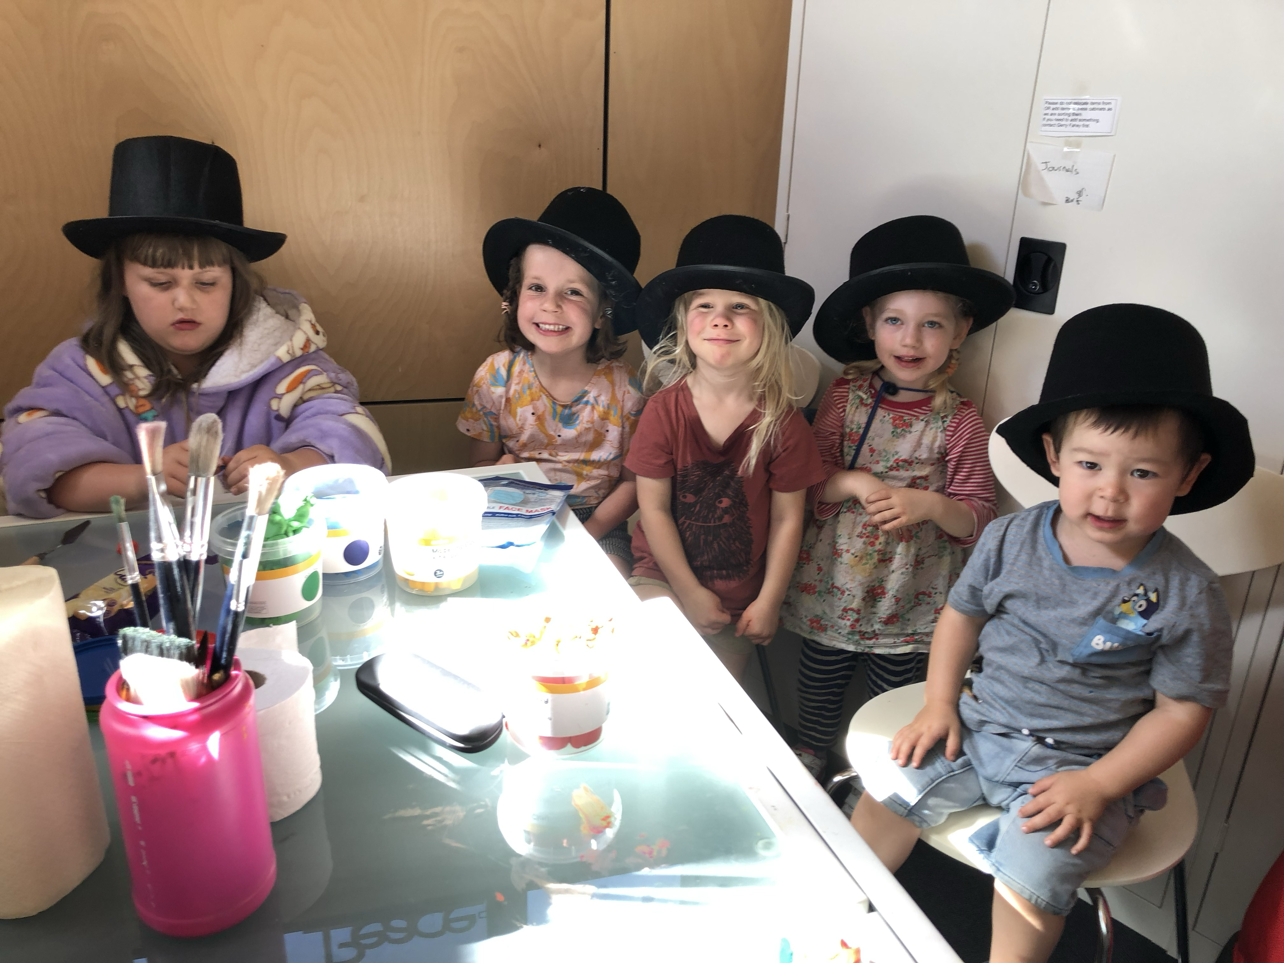
Children’s Meeting at Victorian Regional Meeting – with our hats!

What does this mean for us:
First, it’s important to notice there are many people already working valiantly to generate community and seeking to involve families. Many of the ideas below come from them.

Second, this is not totally new. Our Quaker ancestors could clearly see these were issues needing to be addressed and have wisdom to offer:

Advices and Queries 21: Rejoice in the presence of children and young people in your meeting and recognise the gifts they bring. Remember that the meeting as a whole shares a responsibility for every child in its care. Seek for them as for yourself a full development of God’s gifts and the abundant life Jesus tells us can be ours. How do you share your deepest beliefs with them, while leaving them free to develop as the spirit of God may lead them? Do you invite them to share their insights with you? Are you ready both to learn from them and to accept your responsibilities towards them?

Advices and Queries 26: Children and young people need love and stability. Are we doing all we can to uphold and sustain parents and others who carry the responsibility for providing this care?

How can we build an inclusive Quaker community that reflects our Quaker values?

We need to remember that inevitably there will be a variety of perspectives and preferences about how to do this and ensure we build in enough continuity and /or other processes to remember what we learn. Here are some suggestions shared by many contributors:

Individuals:
- Come to Meetings and related activities wherever possible knowing that your presence is valued in welcoming children and families;
- Ensure all voices including those of children and JYFs are heard: name what works for you and them: remind the Meeting of the joys of including children and JYFs and families;
- Contribute what you realistically can in the hope and expectation that if everyone does this, things will work out;
- Share where possible the joys and challenges of Quaker parenting and grandparenting in our current secular society
- Balance desire for structured activities with allowing children/JYFs so play or hangout together.

In our Local Meetings (note some of these might also happen at Regional Meeting):
Formally:
Have diverse activities to suit different age groups and needs that allow people to come to know each other more deeply as well as to worship together (see Appendix for ideas).
Celebrating: For example, welcoming babies into Meeting with a specific celebratory event where people might also offer clothes and equipment they no longer need.
Discussing and planning what activities (include Meeting for Worship at times) need paid child care and what can be managed by the Meeting.
Plan excursions, specific planned activities in localities that suit everyone including families.
Have a child care roster available publicly to sign up to for Meeting for Worship times.
Annually review the provision for children and JYFS : space, toys and books: make sure they are still in good condition, appropriate for a range of ages and personalities and invite creativity.
Make explicit that children are welcome either at every Meeting and/or at regular Children’s Meetings that might be fortnightly or monthly.
Consider setting up a children’s corner in the Meeting room and other rooms, with resources for quiet activities, cushions or beanbags to sit on, ideally at the centre of Meeting.

Informally:
Develop and maintain a culture of flexibility and responsiveness: relish and adapt to constant change as everyone, including children changes over time. Ask what works and what needs to change? What else could we do?
Seek ways to foster a sense of belonging and knowing each other such as welcoming a newcomer, talking to a child or JYF.
Look out for anyone who doesn’t look included after Meeting.
Build in more tea/coffee, lunch after Meeting.
Invite a new or isolated Friend to come for a cup of something or lunch/dinner.
Send birthday cards to children and JYFs.

How do we symbolically show we welcome everyone?
- Children’s information in front window of Meeting House
- Noticeboards with children’s photographs or drawings
- Cater for neurodiversity – e.g. understanding need to rock, providing yoga balls and hand fidgets
- Spaces for different groups – children’s spaces, both in buildings and externally eg garden either as part of Meeting house space or near park.
- Be explicit about how much everyone can permeate the space: can everyone go everywhere?
- Space and/or acceptance of different levels of energy, i.e. accepting children’s energy and need for physical activity.
- Have the Meeting space be safe, child and diversity friendly.

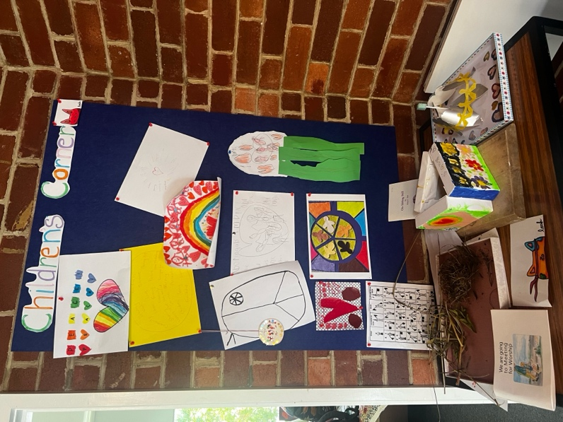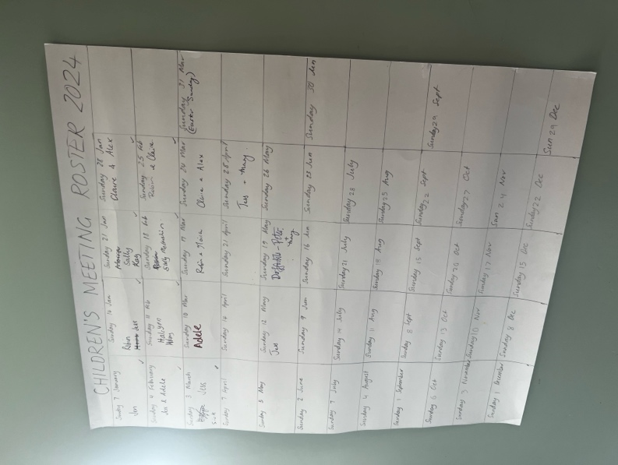
The Children’s Corner and the Roster on the door of the Children’s room Tasmania Regional Meeting.

Regional Meetings:
- Appoint a Regional Meeting Children’s/JYFs Correspondent and Committee
- Encourage Friends to volunteer to organise activities that include all ages
- Organise activities such as Regional Meeting gatherings at times that suit families with a balance of structured and flexible time for a day or weekend.
- Encourage everyone who feels able to register as a child carer and ensure there are annual workshops re child protection processes.

Specifically, at AYM level:

Funding for the CJYFS Committee to:
Employ a one day a week CJYFs coordinator for a three year period to allow for continuity (see appendix for suggestions re duties).
Employ registered child carers as the CYFS Committee assesses are needed for activities such as the Easter Gathering and Yearly Meeting or Meetings for Worship – and encourage Regional Meetings to provide this too.
Fund payment for children/JYFs to go to YM. Have YM activities that include every group as well as for different age levels.
Have a fund for activities suggested by families and/or Meetings that foster parents and/or children and/or JYFs coming together.

The Website made more accessible re information on children and families: connections, activities and resources as well as the organisational structures in AYM that relate to families: this would include the role of the CJYFs Committee and Regional Meeting correspondents/cooordinators.

Consider having a newsletter specifically for families (supported by the Communications and Publicity Manager) or aiming to ensure weekly content from families in Streamlines, the AYM newsletter available free to all Quakers. Some JYFs would appreciate more on the Website related to who is a Quaker and what do they believe?

Simplify data collection and completion of forms for activities including the information needed for Child Protection (explore the use of prefilled forms). Clarify when parents can informally leave their children with other parents.

Invite two JYFs to be on the CJYFs Committee.

Encourage communication and sharing of experience between CJYFs correspondents/coordinators from different Regional Meetings for example, about who is doing what, ideas about how to include families, sharing results of the annual review (see below) of what’s working and not working for your Meeting.

Ask the Programs and Learning Committee at Silver Wattle (or, if not possible, elsewhere) to host monthly zoom gatherings facilitated by the Coordinator: Sharing the challenges and joys of being a Quaker parent.

Organising train the trainer re faith and play and related activities (see below).

Encourage Sojourn Times at Silver Wattle where those of similar ages can have holiday time together with the structure organised as needed by the group.

For all Meetings:
Using these queries to have a regular, at least annual review discussion in your Regional and Local Meetings about these issues (note this should be a Meeting that is part of a whole community discussion not only for parents and/or child carers):

How does your Meeting include all ages in worship and in other activities?
How do you generate a sense of community where all are welcome and feel known?
What space and resources are there for children and Junior Young Friends? Are these realistic for a range of ages and the energy of children? Have resources been reviewed and pruned or expanded as appropriate? Could other parts of buildings to adapted for more flexible use?
How are parents supported in their own spiritual growth and in their exploration of what it means to be a parent in a Quaker community?
How are the needs of all ages and diversities balanced to be inclusive?
How do you find out from families, including children and young people what would make Quaker community for them and what ideas they have about activities?
How do you remain creative in your approaches to forming community in your Meeting?
How are you ensuring children and JYFs are safe in your Meetings? Are there physical or communication changes needed? Does your Meeting need training?
How do you make sure that caring for children is a shared responsibility not delegated to one or two people in the Meeting?
Can your Meeting activities be in or close to the natural environment?

Appendices:

Resources and Activities:

Ways of including children and JYFs in Meeting for Worship:
Have children come in for 10 – 15 minutes at the beginning or end. Some Meetings prefer the beginning – while everyone is settling in and arriving; others prefer at the end so children come into a gathered Meeting and then an option is to ask about what they did in the rest of the hour. Children in some Meetings might stay in Meeting perhaps on cushions in the centre or in a corner of the room reading, drawing, other quiet activities. Need to affirm that some noise is inevitable and part of life – will be other noises not child related that Friends simply let go. Faith and Play is a way to include everyone in a Meeting for Worship with a focus (see below). Note that some JYFs may want to stay for all of Meeting for Worship.

Faith and Play (there is a version of this called Godly Play).
Faith & Play Stories is a Montessori‐inspired, experiential storytelling resource for Quaker religious education programs and Friends schools. Faith & Play stories explore Quaker faith, practice, and witness using the Godly Play method of storytelling and building spiritual community. Faith & Play Stories develops stories for publication and offers training for Friends interested in using Godly Play and Faith & Play. https://quaker.org/faith-play-stories/

Several people talked about the value of using a Faith and Play story in a Children’s meeting or at a camp/gathering. There are now four people in AYM who have had training in Faith and Play and it is recommended that we others are funded to go to training.

Resources for Sessions during MFW with Children and JYFs (NB recognising challenges of mixed ages).

Quaker First Day School in a Backpack: Essential resources for sessions with children.
Have in something easily stored and transported:
Paper, coloured pencils, post it notes, several books to read.

Resource Box for all Meetings:
Paper, coloured pencils, pens, post it notes
Clay
Books for range of ages.
Ideas for sessions that can be organised at short or no notice:
For example:
- Take children for a walk, ask them to notice how the season is influencing what they see, get them to pick or photograph something that catches their eye, link to care for the environment.
- Have mandala sheets to colour in: ask children what thoughts they had, what they liked about doing these – link to being in Meeting for Worship and having meditative time.
- Read a story and ask them to draw what stood out for them and then encourage them to share what and why.
- Learn a Quaker song
- Ask them to make something with clay – ask about what’s made, see how that can lead to deeper conversations and concerns.
- Do a guided meditation suitable for the ages of the children/JYFs you have and get them to share what that was like – examples here:
https://www.greenchildmagazine.com/free-meditation-guided-relaxation-scripts-kids/#h-links-to-sample-meditation-scripts
- Share something of your journey as a Quaker, how your spiritual experience evolved from being a child to now. (Keep short if younger children, longer if JYFs). Ask them to draw an image or put a word on a post it note to reflect their reaction, then explore these.
- With group of JYFs that know each other, ask what makes them hopeful about how the world can be and what challenges them?

Resources with ideas:

Journeys in the Spirit from the UK:
https://www.quaker.org.uk/communities/children-and-young-people-2/i-work-with-children-and-young-people-in-a-quaker-setting/resources-children
This has so many resources! You could print some out for your Meeting.

Read Tracey Bourne’s Backhouse Lecture for ideas re shared MFW pages 29, 38 – 41 particularly (link at end of report).

Specific Activities for different age groups:
Aim to have 2 – 4 events a year for children and/or JYFs depending on ages.
For example, having a monthly pizza or soup night on a Sunday afternoon/early evening for JYFs combined with games they might suggest or a Q and A activity.
Going to see a film/concert or other activity together.

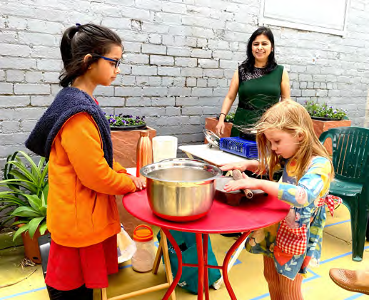
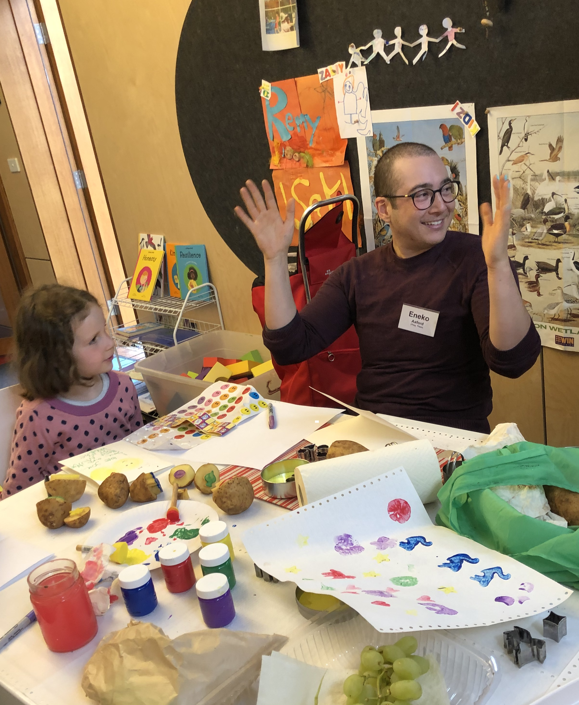
Children learning how to make Indian bread in Creating images! Victoria Regional Meeting.
the courtyard at VQC.

Celebratory activities:
VRM has been having ‘baby showers’ – an all age gathering to welcome a new baby or babies into Meeting. A Friend takes responsibility to provide refreshments, a card and/or present for the baby/family and to get people to share something in a worship sharing way eg what they value in parenting/children. Friends are invited to bring second hand clothes or equipment for babies/children they no longer need. NB great for celebration and encouraging environmentally sustainable practices.

Could do other welcoming activities: knit baby blankets, send a card, take a meal to new parents.

Have celebrations for other activities: send children and JYFs a birthday card annually.

Camps/ Weekends Away.

These are really useful way of allowing space for people to get to know each other more deeply and form mutually supportive connections. They do take a some organising and it helps to have some people with a commitment to this - perhaps as a particular one off project they can offer. People vary about how structured this needs to be and how much planned in advance. Clearly you need to work out accommodation, costs, space, timelines about when you expect people to commit to coming. You can ask people who are coming to suggest or volunteer to do specific sessions. You need a balance of the ideas and resources above with unstructured time to walk/play/hang about particularly for older children and JYFs.

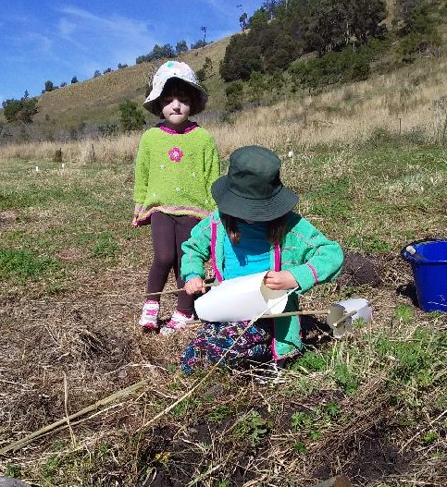
Planting trees at Silver Wattle

A possible Job Description for a Children’s and JYF’s Coordinator:

The Children and Junior Young Friends Coordinator is appointed by the Children and JYFs Committee (a Yearly Meeting Committee) for a three year term. The Coordinator will work across Yearly Meeting to foster inclusion of children, junior young friends and families. This will include resourcing local and Regional Meetings to provide activities as well as to encourage communication and mutual support between them.

The Coordinator will be responsible to the Children and JYFs Committee and is expected to attend and report to monthly Committee Meetings. The hours of work will average out to one day a week over a year, with four weeks annual leave.

Qualifications and Experience.
A leading to build all age participation across Yearly Meeting, with particular focus on children, junior young friends and families.
Knowledge and understanding of Quaker processes and culture, worship and practice.
Relevant qualifications and/or experience in a relevant field such as child care or youth work, group or community work, teaching or training, peacebuilding, interfaith work or other experience seen as relevant.

Skills and Qualities:
Excellent communication skills both verbal and written.
The capacity to network effectively to build relationships and connections between Friends interested in nurturing children, JYFs and/or parents.
Interpersonal skills including the ability to encourage and empower others to share in developing and implementing activities and resources.
Practical skills in planning and organising events and training others to share these.
Ability to work independently.
A commitment to inclusivity with the ability to embed this in activities and processes.

Duties or Key Tasks:
- Coordination and Fostering Activities for Children, JYFs and parents:
  - Work with Yearly Meeting to continue to explore the hopes for actively including all ages in Quaker activities. This might include asking all members and attenders annually for ideas and feedback;
  - Actively encourage the development of specific Yearly Meeting or across Regional Meeting activities which provide opportunities for children, young people, parents, grandparents and others to experience both separate age appropriate and intergenerational, integrated community;
  - Contribute where needed to fostering local or Regional Meeting activities and generating resources for Meetings and individuals;
  - Where needed and requested, support and nurture volunteers involved in planning and delivering programs including Quakers providing training to each other;
  - Manage the budget for activities allocated by Yearly Meeting;
  - Build in ways for participants to articulate the value of activities and resources as well as anything that needs to change;
  - Liaise with the Child Protection Committee as needed providing feedback about what is working and not.

- General Communication and Organisational Tasks
  - In consultation with the Communication Director, keep the AYM website updated in relation to Children’s Coordinators at each Regional Meeting and relevant information about families and ages of children and JYFs and of activities of interest to families including welcoming new babies;
  - Ensuring a form of communication happens with and between families such as a newsletter and contributing where appropriate;
  - Maintaining an easily accessible record of what has and hasn’t worked so that those involved can build on what has been learnt in the past;
  - Contribute as needed in planning and delivering events to timed deadlines.

Specific requirements:
Being willing to work flexibly given need to participate in some weekend activities.

Remuneration and benefits:
Salary:
Annual leave:
Superannuation.

References:

Bayes, Helen (2003) Respecting Rights of Children and Young People: A New Perspective on Quaker Faith and Practice. The James Backhouse Lecture: https://www.quakersaustralia.info/sites/aym-members/files/pages/files/2003%20Lecture.pdf

Bourne, Tracey (2014). Our life is love, and peace, and tenderness Bringing children into the centre of Quaker life and worship. Backhouse Lecture: https://www.quakersaustralia.info/sites/aym-members/files/pages/files/2014%20Lecture.pdf

Finding our truth, community and journey as Australian Young Friends (2010) The James Backhouse Lecture. https://www.quakersaustralia.info/sites/aym-members/files/pages/files/2010%20Lecture.pdf

