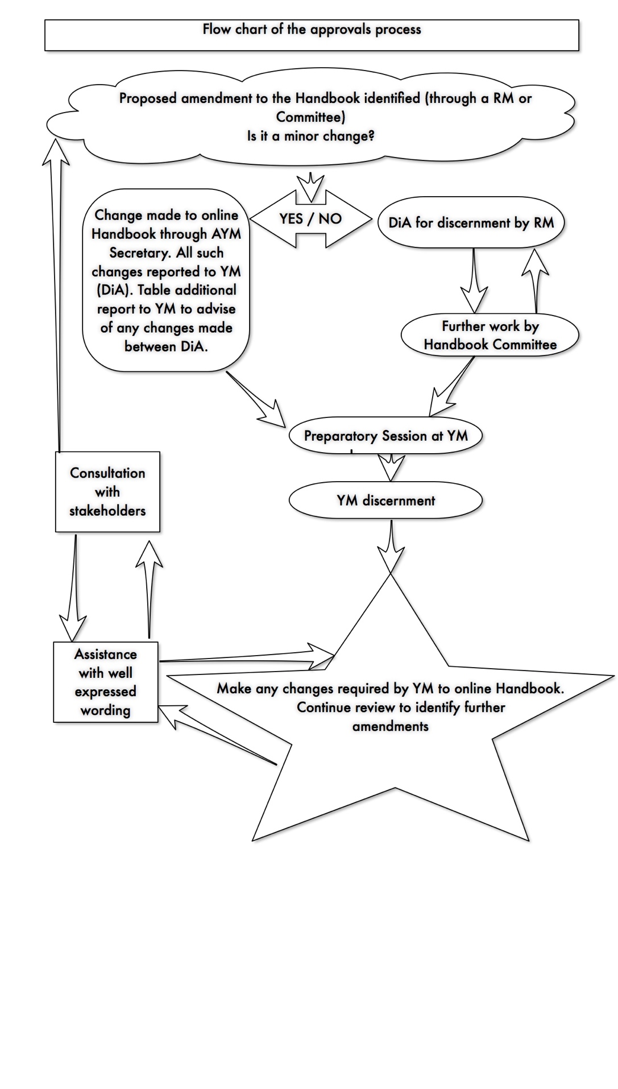

**Handbook Flowchart as at 1st July, 2020 (Edition 7)** release)