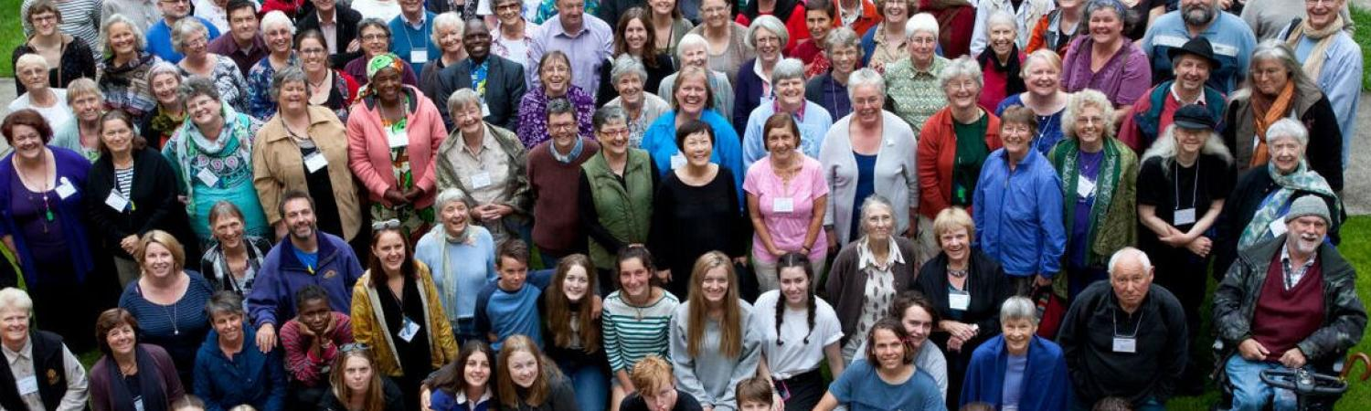
Invitation to Australia Yearly Meeting, July 2020
Australian Friends gather each year for their Yearly Meeting for Worship for Business. Also, for learning, sharing and living in Quaker community for a week. Each year we invite a Friend, known as our Visiting Friend, from the Asia-West Pacific Section of FWCC. The intention of the Friend’s visit is to increase the links between Australian Quakers and other Friends in the AWPS region.
We invite applications from interested Friends who will be asked to:
- participate in the Yearly Meeting
- give a presentation to Australian Friends sharing their Quakerism, Quaker community and culture
- travel to other parts of Australia to share with Quakers
On returning home we would like them to share with Friends and others their experiences in Australia.
Costs:
Australian Friends cover the costs for one Friend - visa, travel insurance, airfares, internal fares, accommodation, meals and incidentals.
Time:
Two to four weeks in June-July including Yearly Meeting 2020 (4-11 July)
If you wish to be considered send the attached application which must include:
- A simple background statement about your life and interests, especially as a Quaker
- What you hope to share with Australia Yearly Meeting
- How the visit is likely to benefit Friends in your community
- How the visit can support your work in your locality or region

We also expect a supporting minute or statement from one of:
- your Quaker Meeting
- the FWCC AWPS executive, or
- another Quaker source

Communication:

We need to know the best way to be in touch with you. We can Zoom, Skype and email or phone so we can talk to you.

Thank you. We look forward to hearing from you.

Jacqueline Schultze
Australia Yearly Meeting Secretary
The Religious Society of Friends (Quakers) in Australia

Application to be a Visiting Friend to Australia Yearly Meeting,
July 2020

Personal Name……………………………………………………………………

Family Name…………………………………………………………………………………….

Sex……………………… Date of Birth ………………………………………………….

Nationality……………………………………………

Home Address…………………………………………………………………………………………………………

………………………………………………………………………………………………………..

Postal Address……………………………………………………………………………………………………………

…………………………………………………………………………………………………………………………….

Email……………………………………………

Phone including codes…………………………………

Best way to contact you to set up a video meeting - Email or Phone? …………………………………………….

Please tell us about you:

1.A simple background statement about your life and interests, especially as a Quaker

Please tell us
- What you hope to share with Australia Yearly Meeting?

- How the visit is likely to benefit Friends in your community?

- How the visit can support your work in your locality or region?

- Please attach a supporting minute or statement from one of:
  - your Quaker Meeting
  - the FWCC AWPS executive, or
  - another Quaker source
OR tell us who will be providing that statement .…………………………………………………
AND
Their email contact …………………………………………………………….

and Phone number with all codes. ……………………………………………………….

Email your application to: CFWCC@QuakersAustralia.info

Thank you for your application
We will contact you as soon as we can.

