17 April 2024

QUAKER PEACE AND LEGISLATION COMMITTEE STATEMENT
ON ARMS SALES TO ISRAEL FOR USE IN GAZA

Dear Richard Marles,
The crisis in Gaza has reached a point where every effort must be made to stop the violence being inflicted on the people there by Israel. The following moves have clearly shown that the situation demands urgent action by governments:
- The International Court of Justice (ICJ) has expanded the provisional orders to all states to prevent further attacks on the people of Gaza, the United Nations Security Council has voted for an immediate ceasefire, and the UN Human Rights Council has called for an arms embargo.
- In the USA, 56 members of Congress, and six humanitarian agencies working in Gaza, have called on President Biden to halt weapons shipments to Israel.
- In February 2024 the Dutch Appeals Court ordered the government of the Netherlands to stop the export of F-35 bomber parts to Israel, citing a clear risk that it was being used to commit war crimes in Gaza.
- The Jewish Council of Australia has called on state and federal governments to cut all military ties and place sanctions on Israel as part of Australia's responsibility to the ICJ to prevent Israel committing genocide in Gaza. This echoes the ongoing urgings from Palestinian groups for similar action.
- There is evidence that the statements by the Australian Government that it has stopped the shipment of 'whole' weapons (aircraft, tanks etc) to Israel are disguising the fact that components and parts (eg drones, robots, ammunition) are still being sent there by companies that have already obtained export licences.
- The Future Fund continues to hold investments in the largest Israeli bomb-market Elbit Systems.

We acknowledge the Government's support for the recognition of Palestine as a state as a basis for longer-term negotiations of a peaceful settlement in the region. We also acknowledge the Foreign Minister and Prime Minister for their recent moves (including at the UN) to place more pressure on the Israeli government to reach a ceasefire/ hostage agreement that will enable humanitarian aid to flow more quickly to Gaza. We urge further steps by the Government including:
(a) recalling the ambassador to Israel for talks on the situation,
(b) placing travel restrictions on those involved in warmaking,
(c) restoring full financial support for aid agencies working in Gaza, and
(d) issuing detailed evidence to confirm that no armaments (whole or part) are
being exported to Israel.
Sincerely,

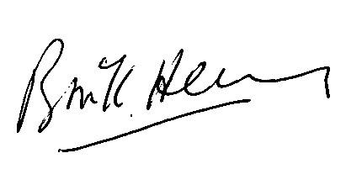

Bruce Henry
Presiding Clerk
The Religious Society of Friends (Quakers) in Australia

CC: Senator Penny Wong, Minister for Foreign Affairs; Senator Simon Birmingham, Shadow Minister for Foreign Affairs; Andrew Hastie, Shadow Minister for Defence of Australia

