Thales
‘Building a future we can all trust’- Thales company slogan

Global CEO Patrice Caine: ‘has his eye on Australia as a development centre’

Global HQ: Tour Carpe Diem, 31 Place des Corolles - CS 20001, 92098 Paris La Defense Cedex
+33 (0) 1 57 77 80 00
Thales defence revenue in 2019 was $9.251 billion. Thales is the 8th largest defence contractor in the world.

Thales has offices in:
Africa: South Africa,^{[42]} Egypt,^{[43]} Morocco.^{[44]}
Asia: Saudi Arabia, United Arab Emirates, Qatar, Pakistan, India, China, Hong Kong, South Korea, Singapore, Japan, Vietnam, Taiwan^{[45]}
Europe: Norway, United Kingdom, Netherlands, Germany, Belgium, France, Switzerland, Austria, Romania, Poland, Italy, Spain, Portugal, Hungary, Turkey
Oceania: Australia
North America: Canada,^{[46]} Mexico, United States
South America:^{[47]} Brazil, Argentina, Dominican Republic.

Thales Australia
CEO: Chris Jenkins
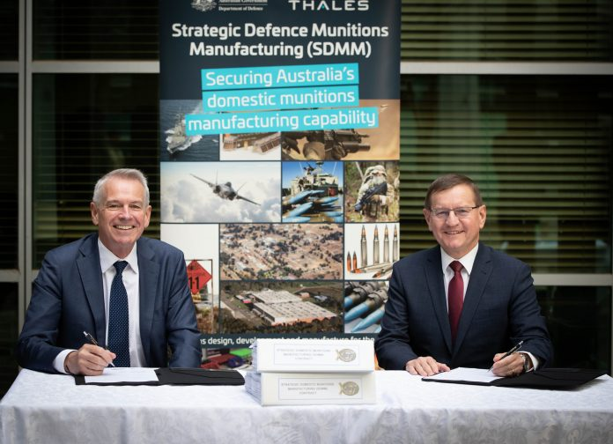
CEO Chris Jenkins happily signing a deal with Dept of Defence rep Ivan Zlabur for $1 billion of our money to make bombs and bullets in Benalla
Finn St, North Bendigo VIC 3550
Tel: +61 3 5440 4311
+61 (0)2 8037 6000 communications@thalesgroup.com.au
+61 (0)2 8037 6000 sales@thalesgroup.com.au
Australia & New Zealand Press Enquiries
+61 (0)404 073 169 alasdair.cameron@thalesgroup.com.au
https://www.thalesgroup.com/en
Australia has Prime Corporation status – and is one of 8 “primes” in the Global Supply Chain Program. This is primarily about grooming Australian companies to make military exports.
Locations: Bendigo - Armoured Vehicles, Benalla - Munitions
$1.6 billion of exports from Australia in past ten years
In 2006 Thales acquired Australian Defence Industries, a major manufacturer of military equipment such as smokeless gunpowder and the Bushmaster IMV.
In February 2018, Thales won on a A$1.2 billion ($946 million) contract with Airservices Australia and the Australian Department of Defence to unify Australia's civil and military airspace under a single air traffic control system, named "OneSKY".^{[26]}
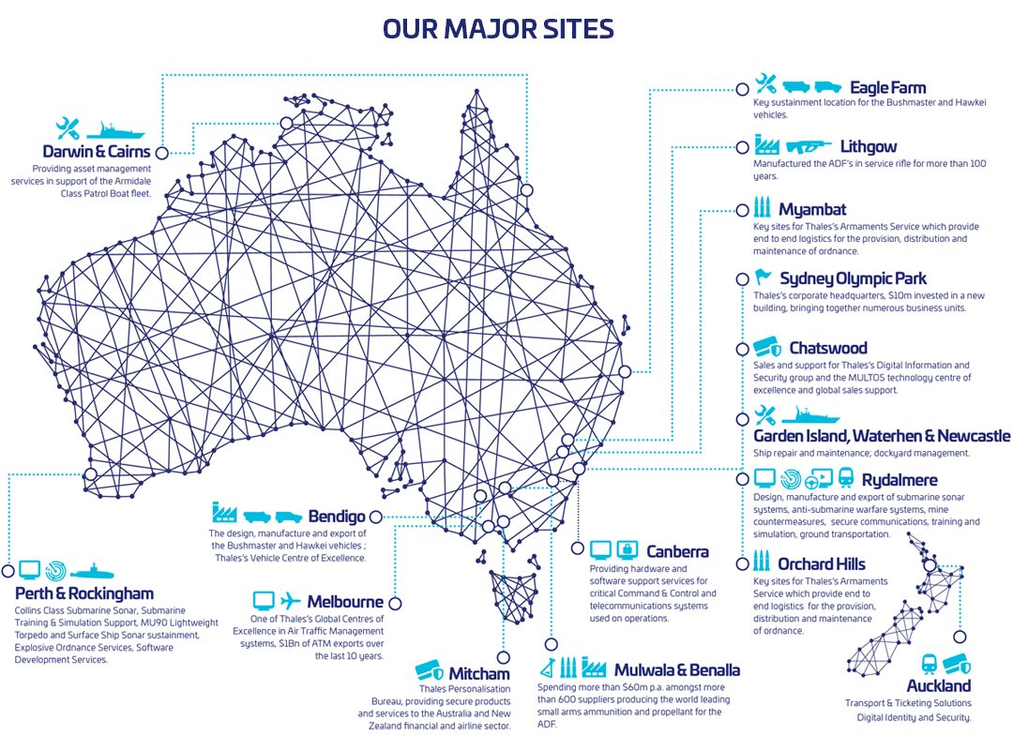
Armoured Vehicles/Tanks
2013 Thales sold 3 Bushmaster vehicles to Kopassus. This was a govt to govt contract worth $2.7 million, brokered by AMSO
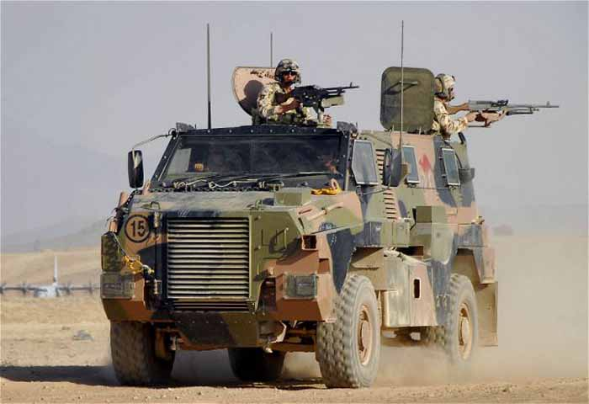
Thales Bushmaster
2016
During the fourth Ministerial 2+2 dialogue with Indonesia on October 27 2016, senior Australian defence industry officials signed a collaboration agreement to further develop a mine-resistant armoured vehicle which was launched at IndoDefence 2016 exhibition in Jakarta.
According to the official joint communique, issued by Australian Foreign and Defence Ministers Julie Bishop and Marise Payne and their Indonesian counterparts Retno Marsudi and Ryamizad Ryacudu, the design is based upon the Australian Bushmaster design developed by Thales Australia.
Thales and Indonesian armoured vehicle manufacturer PT Pindad will cooperate on the design, which would be customised for Indonesian Army (TNI) needs. The vehicle is called the Sanca.
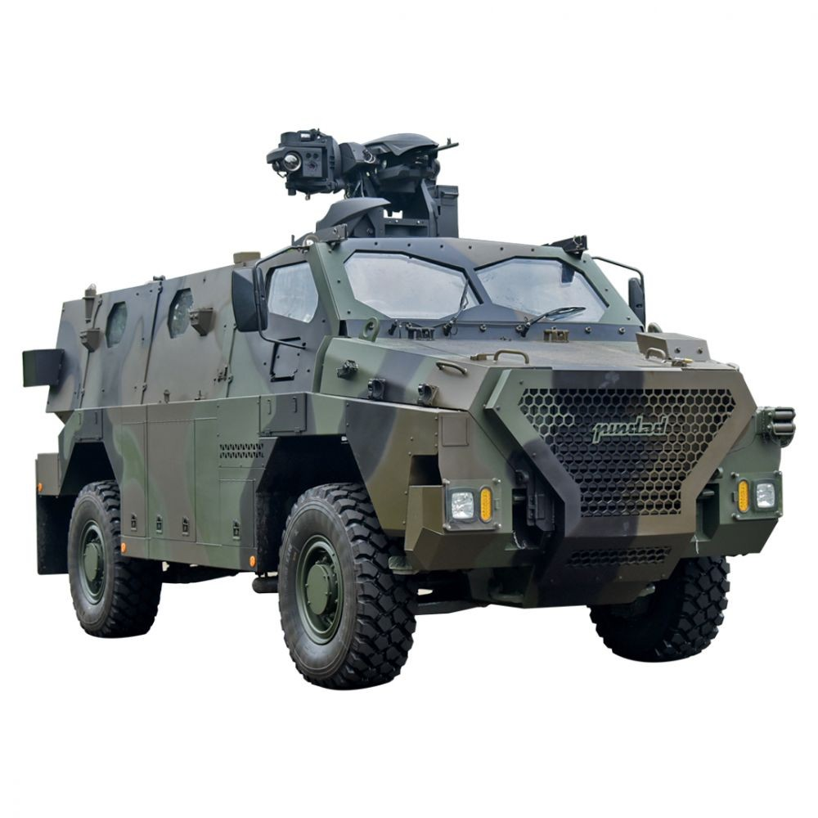
Thales-Pindad Sanca APC

MUNITIONS
2018
The Australian government announced Monday (29 June) two deals with munitions suppliers that should help secure hundreds of Australian jobs for another decade. Defence signed a new agreement with Thales Australia for the continued management and operation of Australia’s munition factories in Benalla (Victoria) and Mulwala (New South Wales). The A$1.1 billion agreement provides ensures the supply of key munitions and components for the Australian Defence Force (ADF). The government also signed a deal with supplier NIOA Munitions.
Thales manufacture the following ammunition:
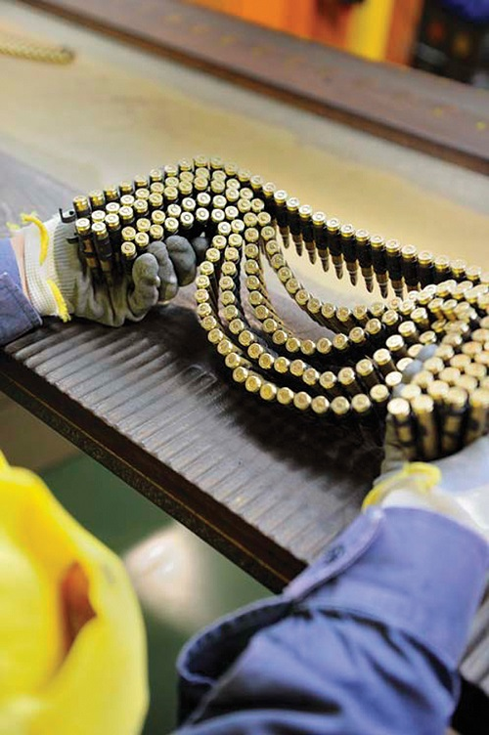
Thales bullets
5.56 mm M193/NATO SS109 and L110
5.56 mm/7.62 mm brass & plastic blank
7.62 mm NATO ball/tracer
.50 cal ball
20 mm phalanx and M55 full and sub-calibre projectiles
30 mm DEFA air-to-air and air-to ground
40 mm Q/F For practice Mk6, practice Mk 1 and 1 A/T Mk4 and HE
81 mm mortar augmenting charges
105 mm Tank
105 mm Tank L7 For L35A3 or L56A1
105 mm Howitzer M2 & M4 Zones 1–2 for M67, HE shell
105 mm Howitzer M2 & M4 Zones 3–4 for M67, HE shell
105 mm Tank L7 HESH
105 mm Tank L7 APPSDS
5”/54 naval
155 mm Ho witzer Zones 3–7 for M4A2.
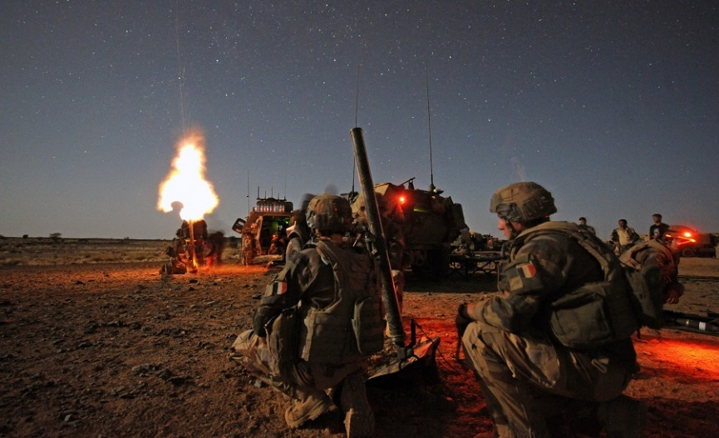
This Thales Mo 81 LLR is ‘very easy to use’
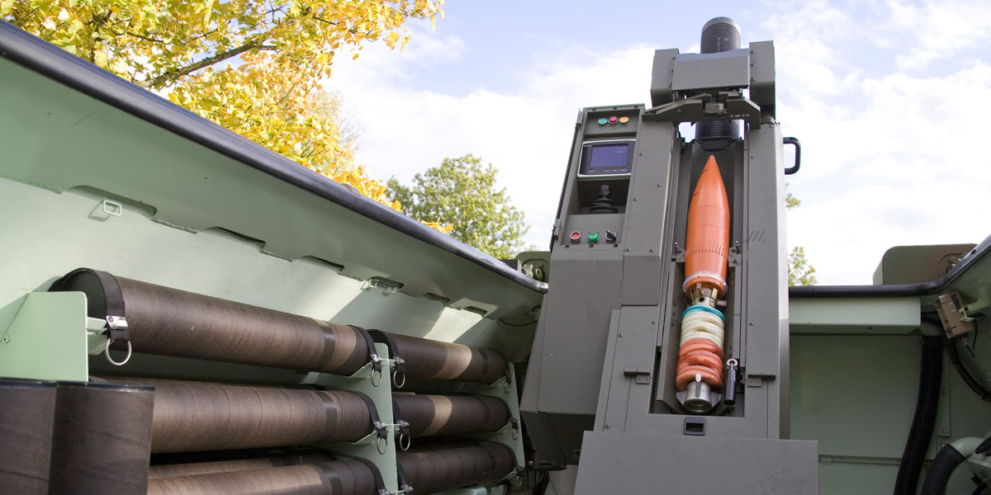
Thales mortars are masterpieces of ‘modern industrial technology’
Apparently they will last forever (but only if you never use them)

Questionable Practices In the Realms of Corruption 2
Revolving Door and Undue Influence

Thales and the Revolving Door
Brendan Nelson, former Defence Minister, was on the "advisory board" between 2015 and 2019. 1
Former ASIO boss Duncan Lewis joined the Thales board 5 months after he left ASIO 1
Thales and "Undue Influence" 2
"Defence recommends buying hundreds of vehicles from Thales, despite no need for them, just so Thales can keep its factory open" Fahy 2
Thales appears to be expert in exerting undue influence on Governments.
1/ influenced AG Christian Porter to censor key parts of the auditor general's report (ANAO report) into procurement process for the Thales Hawkei vehicle.
2/ influenced the government of 2008-2011 to pursue a high risk program. / 2015 appointed Nelson to its advisory board / Agreed on the contract
3/ The option was $700million higher than the other options
4/ Defence purchased 214 extra vehicles even though there was no need for them $221million associated increase in expenditure. This was to keep the Bendigo plant operating.
5/ Refused to negotiate on prices once it was locked into the "prime" "GSCP" arrangements - the government lost leverage. 2
6/ Appears to have been involved in overpricing to the tune of $16million but this was "investigated" by a friend of the family. 2/3
7/ All of this was hidden and refused until Rex Patrick fought with the government the parts of the audit report that were redacted, visible. The Government was found to have acted wrongly in redacting parts of the report. 4

- https://www.michaelwest.com.au/culture-of-cosiness-colossal-conflicts-of-interest-in-defence-spending-blitz/ 1
- Michelle Fahy reports https://www.michaelwest.com.au/department-of-defence-captured-by-foreign-weapons-makers-thales-bae/ 2
- https://www.theaustralian.com.au/nation/defence/defence-to-investigate-inflated-navy-contracts/news-story/eb3381b5df79b3fc66c7e1c4b3d34449 3
- https://www.theguardian.com/australia-news/2020/dec/09/government-wrong-to-censor-report-to-protect-arms-makers-interests-tribunal-finds 4

From Thales website:

Land Forces 2021
1-3 June 2021
Brisbane Convention & Exhibition Centre
LAND FORCES 2021 is an international industry exposition to showcase equipment, technology and services for the armies of Australia and the Indo-Asia-Pacific.
The biennial LAND FORCES exposition is a powerful forum for key decision-makers from throughout the region, enabling government representatives, defence officials, military procurement managers and senior army officers to network with defence materiel manufacturers, equipment suppliers and service providers.

From Thales Australia:
We’re passionate about preserving the planet for future generations. That’s why we operate in a way that protects the environment, preserves biodiversity and respects natural sites. We’re reducing our footprint by minimising our resources, seeking less environmentally harmful alternatives where we can, recycling and preventing pollution wherever possible.

For more information go to disruptlandforces.org #disruptlandforces
Email info@disruptlandforces.org

Submarines and Thales
Australia’s $80-$100Billion Submarine Contract has gone to Naval Group which is one third owned by Thales.
